Investments Answers to Problem Sheet 6 Lent Term 2024
True-false questions
- If you have split your portfolio between several managers, it is not important how much risk each manager takes because risks are likely to diversify away across managers.
FALSE. It is only the idiosyncratic risk of shares that is likely to diversify away. You are interested in the risk that each manager contributes to the risk of the overall portfolio. So if for example there are a large number of managers each holding equities in the same market, the main risk in the whole portfolio is likely to be market risk, and you will be concerned with the excess return of each manager per unit of market risk.
- The value-weighted return on a portfolio is generally higher than the time-weighted return.
FALSE. There is no necessary relationship between the two. The value weighted return will be higher if there have been inflows before a good year and outflows before a bad year.
- If an actively managed equity portfolio has a Treynor measure of 8% per annum, then the same portfolio combined with a holding of risk free bonds will also have a Treynor measure of 8% per annum.
TRUE. If we put a proportion x into bonds and 1-x into the equity portfolio, the return will be xr_{f} + (1-x)r_{p} while the beta will be (1-x)b_{p}. The Treynor measure is then {( xr_{f} + (1-x)r_{p})-r_{f}}/{(1-x)b_{p}} = {r_{p}-r_{f}}/{b_{p}} = Treynor measure of original portfolio.
- If an actively managed equity portfolio has a Treynor measure of 8% per annum, then the same portfolio combined with a holding of an index fund will also have a Treynor measure of 8% per annum.
FALSE. Using subscript I for the index fund, the Treynor measure of the combined portfolio is {( xr_{i} + (1-x)r_{p})-r_{f}}/{xb_{i} + (1-x)b_{p}}. This equals {r_{p}-r_{f}}/{b_{p}} only if the Treynor measure of the index fund is also 8%.
- If the CAPM holds, then a randomly chosen portfolio will have a Fama measure of zero.
FALSE. The Fama measure penalises portfolios for all risk. A random portfolio will have market risk, which is rewarded, and idiosyncratic risk that is not rewarded. In algebraic terms F = r_{P} – r_{F} – σ_{P}/σ_{M}(r_{M} – r_{F}). If CAPM holds then r_{P} = r_{F} + β_{P} (r_{M} – r_{F}) + ε. So F = (β_{P}– σ_{P}/σ_{M})(r_{M} – r_{F}) + ε = −(σ_{P}/σ_{M})(1-ρ)(r_{M} – r_{F}) + ε which is negative on average. It is the Jensen measure that will be zero on average.
- If the CAPM holds, then all other portfolios are expected to have a lower Sharpe ratio than the market portfolio.
TRUE. If a portfolio has a higher Sharpe ratio than the market than a combination of the portfolio and cash can be constructed with the same expected return as the market but lower risk. The market portfolio would then be inefficient, thus violating the CAPM.
Problems
- An equity fund has £100m under management at the beginning of the year. The following table shows the cash inflows (positive) and cash outflows (negative) that occur at the end of the year and at the end of the two subsequent years. It also shows the fund’s value after these cash flows, and the annual returns on the market portfolio and on T-bills.

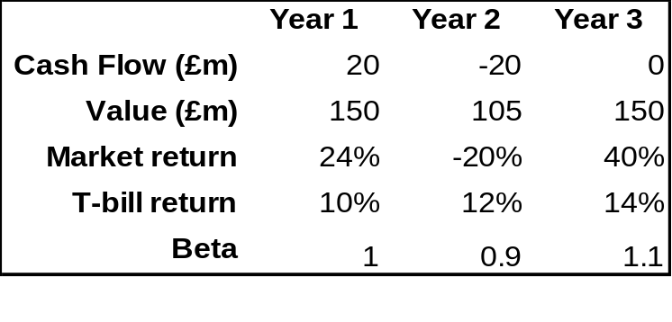
You estimate that the fund’s systematic variance was consistently equal to 85% of its total variance, and that the annualised standard deviation of market returns remained a constant 20% throughout the 3-year period.
- Calculate the time weighted return and the value weighted return on the fund over the three year period. Explain the difference in the two values.
- Calculate the total standard deviation of returns of the fund and the diversifiable standard deviation of the fund in each year.
- Calculate the Jensen and Fama measures and the Sharpe and Treynor ratios for the fund for each year.
- Comment on the performance of the fund.
The relevant calculations are contained in the embedded spreadsheet:
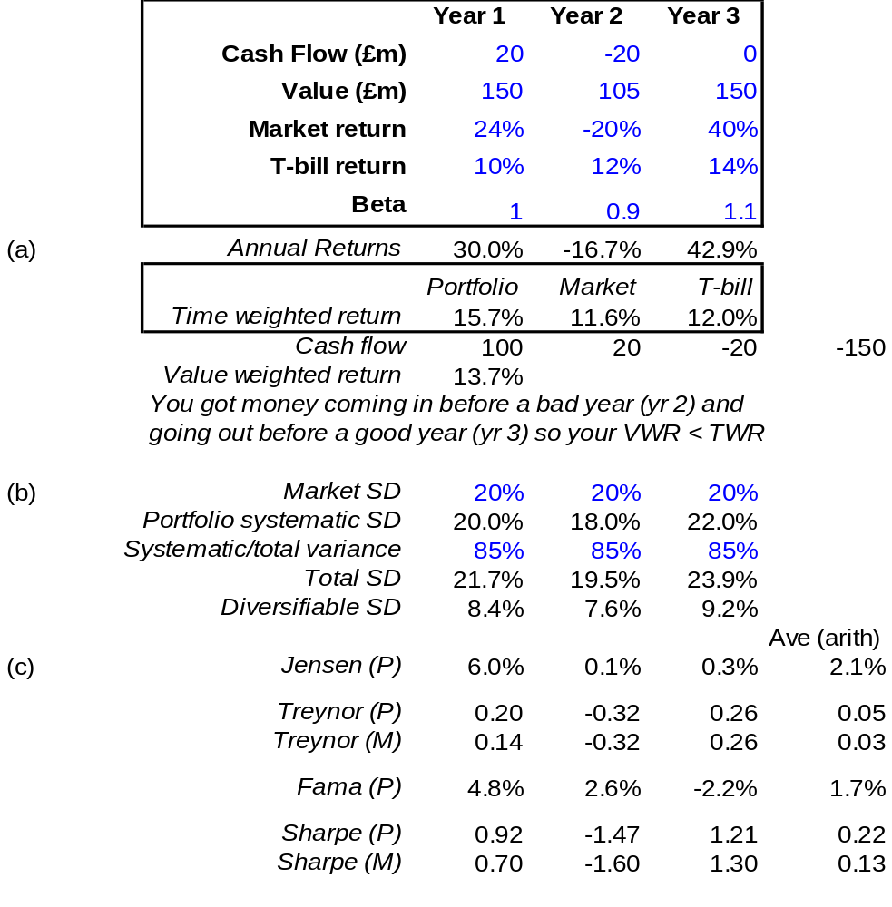
d) Assuming that the manager has no control over cash inflows and outflows, it is the time weighted return that is significant. On this basis, the manager appears to have done well, beating both the market index and cash, with much of the out-performance occurring in the first year. But that is without accounting for risk.
Assuming that the portfolio is one part of a larger portfolio, diversifiable risk is not relevant, so we are interested in the Jensen and Treynor measures. The Jensen measure shows that the manager out-performed the market each year, on average by 2.1%/year, after allowing for market risk. This suggests that the manager has stock selection skills (though the period is short, so the evidence is weak). The negative Treynor ratios for both the portfolio and the market in year 2 are due to the market doing worse than cash that year.
The portfolio actually beat the market by about 4% per annum over the period. The difference between this and the Jensen measure is due to market timing. Although the fund had the same average beta as the market, the beta did vary and this led to an additional benefit. The effect of varying beta is to increase the return each year by the difference between actual and average beta times the excess return on the market:
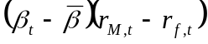
This is 0, +3.2% and +2.6% in the three years, averaging +1.9%/year. This is evidence (again weak) of market timing ability.
If the portfolio is not part of a diversified portfolio, total risk is what matters and we need to analyse the position using Fama and Sharpe. These measures will always look worse than Jensen and Treynor if the market beats T-bills because the portfolio is being charged for total risk and not just systematic risk (the measures will look better in down markets like year 2). The positive Fama measure and the fact that the Sharpe ratio beat that of the market both suggest that the manager earned positive returns even allowing for the total risk.

2. A global equity manager is assigned to select stocks from a universe of large stocks throughout the world. The manager will be evaluated by comparing her returns to the return on the MSCI World Market Portfolio, but she is free to hold stocks from various countries in whatever proportions she finds desirable. Results for one month are given in the following table:
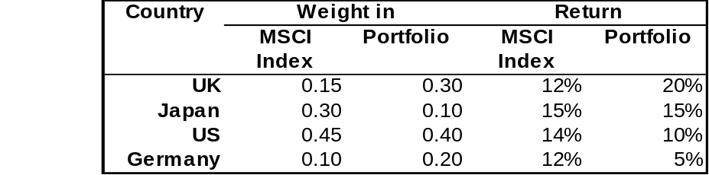
- Calculate the manager’s excess return on the portfolio as whole.
- Calculate the excess due to country allocation decisions.
- Calculate the excess due to stock selection within countries.
- Verify the sum of (b) and (c) is equal to (a).

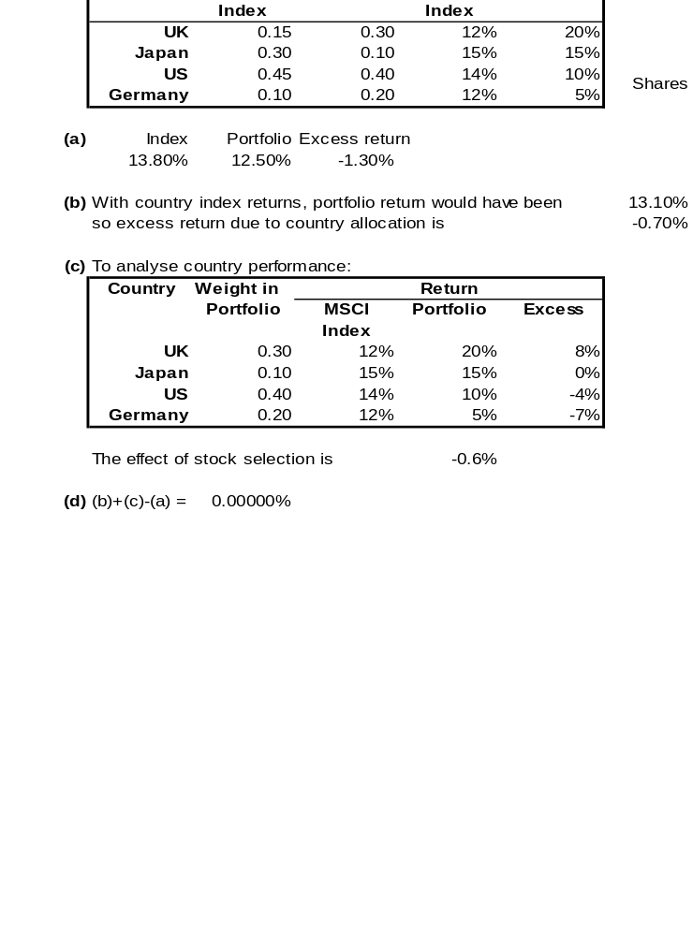
- A portfolio P is invested in two assets A and B, with the remainder being invested in the market M. The diversifiable components of A and B are uncorrelated with each other. Over the last year, you have the following statistics, where T denotes T-bills in which the portfolio was not invested:
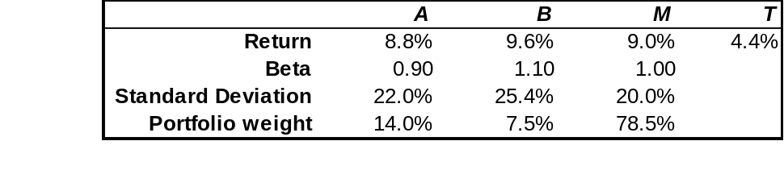
- compute the Jensen measure for each asset and for the portfolio as a whole
- Calculate the idiosyncratic standard deviation for both A and B.
- Calculate the portfolio’s beta, total standard deviation and idiosyncratic standard deviation.
- Calculate the Sharpe ratio of the portfolio and of the market.

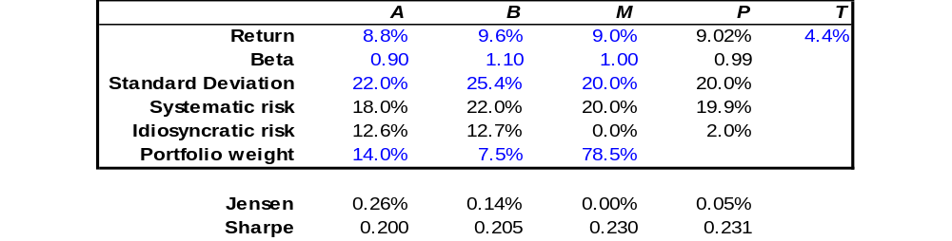
- The portfolio return and beta are simply the weighted average of its components. The Jensen measure can then be computed.
- To get the idiosyncratic risk of A and B, first compute their market risk (beta times the standard deviation of the market) and then compute the idiosyncratic risk by noting that market variance plus idiosyncratic variance equals total variance.
- The portfolio’s beta has already been calculated. Its market risk is its beta times the standard deviation of the market. Its idiosyncratic variance is the weighted sum of the idiosyncratic variances of its components.
- The Jensen measures of both shares are positive, showing that they would improve portfolio performance if added to a holding of the market portfolio. They also have Sharpe measures that are lower than the market showing that neither held alone would be better than the market. The relatively small exposure to A and B does improve the Sharpe ratio of the portfolio. In fact, use of solver shows that this the portfolio that has the maximum possible Sharpe ratio.

